Table 20.1 Random Variable Characteristics

Mean value (also known as expected value or first moment): | 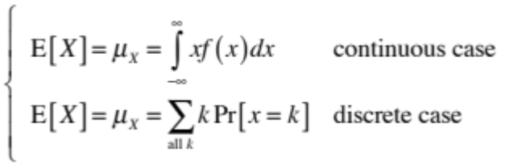
Second moment: | 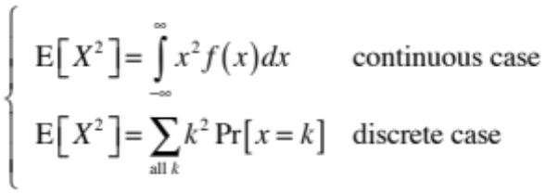
Variance
Standard deviation:

Table 20.2 Autocorrelation Functions and Spectral Densities

Stationary Random Process | Autocorrelation Function | Power Spectral Density
X(t) | RX(τ) | SX(w)
aX(t) | a2RX(τ) | a2SX(w)
X'(t) | –d2RX(τ)/dτ2 | w2SX(w)
X(n)(t) | (–1)nd2nRX(τ)/dτ2n | w2nSX(w)
X(t)exp(jw0t) | exp(jw0τ)RX(τ) | SX(w – w0)

